**Aim:** Design Christmas dual led chaser lights.

**Apparatus:** Arduino, LED’s, Resistance 470 ohm, wires, Breadboard.

Circuit diagram:

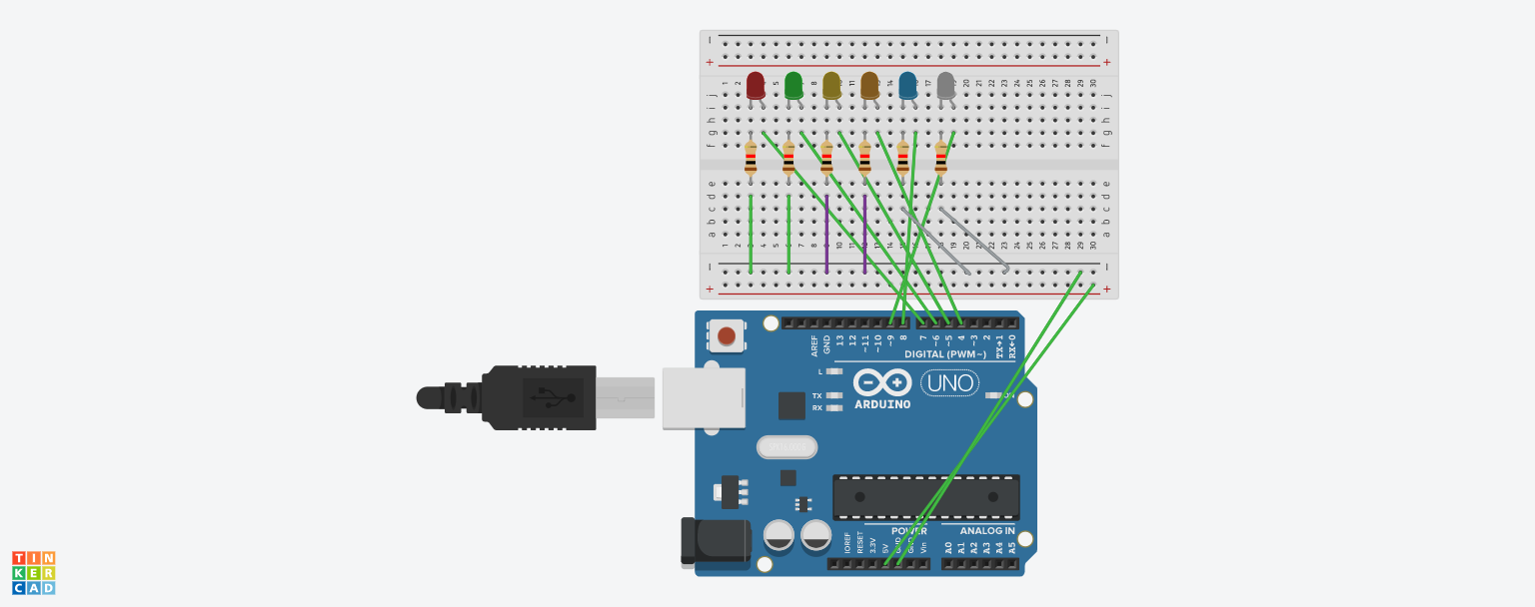

Theory:

This is the **circuit** of a simple **LED chaser**. The LEDs lights one by one for a period of 1second and the cycle repeats giving the running **light** appearance. ... Out of the 10 outputs of IC2, eight outputs are used to drive the LEDs. The ninth output pin 9 is connected to the reset pin 15 to stop the counting.

**Advantages of using led chaser**: **LEDs** emit more lumens per watt than incandescent **light** bulbs. The efficiency of **LED** lighting fixtures is not affected by shape and size, unlike fluorescent **light** bulbs or tubes.

**precaution:**

1. do not use resistance below 10k.
2. wire should be inserted properly and tightly.
3. Check led before using in the circuit whether working or not

**Learning outcomes:**

Learnt working of Arduino uno and coding. How to install this code in christmas lighting.

**Observation:**

Light is blinking every second.